**PIZZA SALES SQL QUERIES**

**KPI’s**

**1.TOTAL REVENUE**

select sum(total_price) as Total_Revenue from pizza_sales;

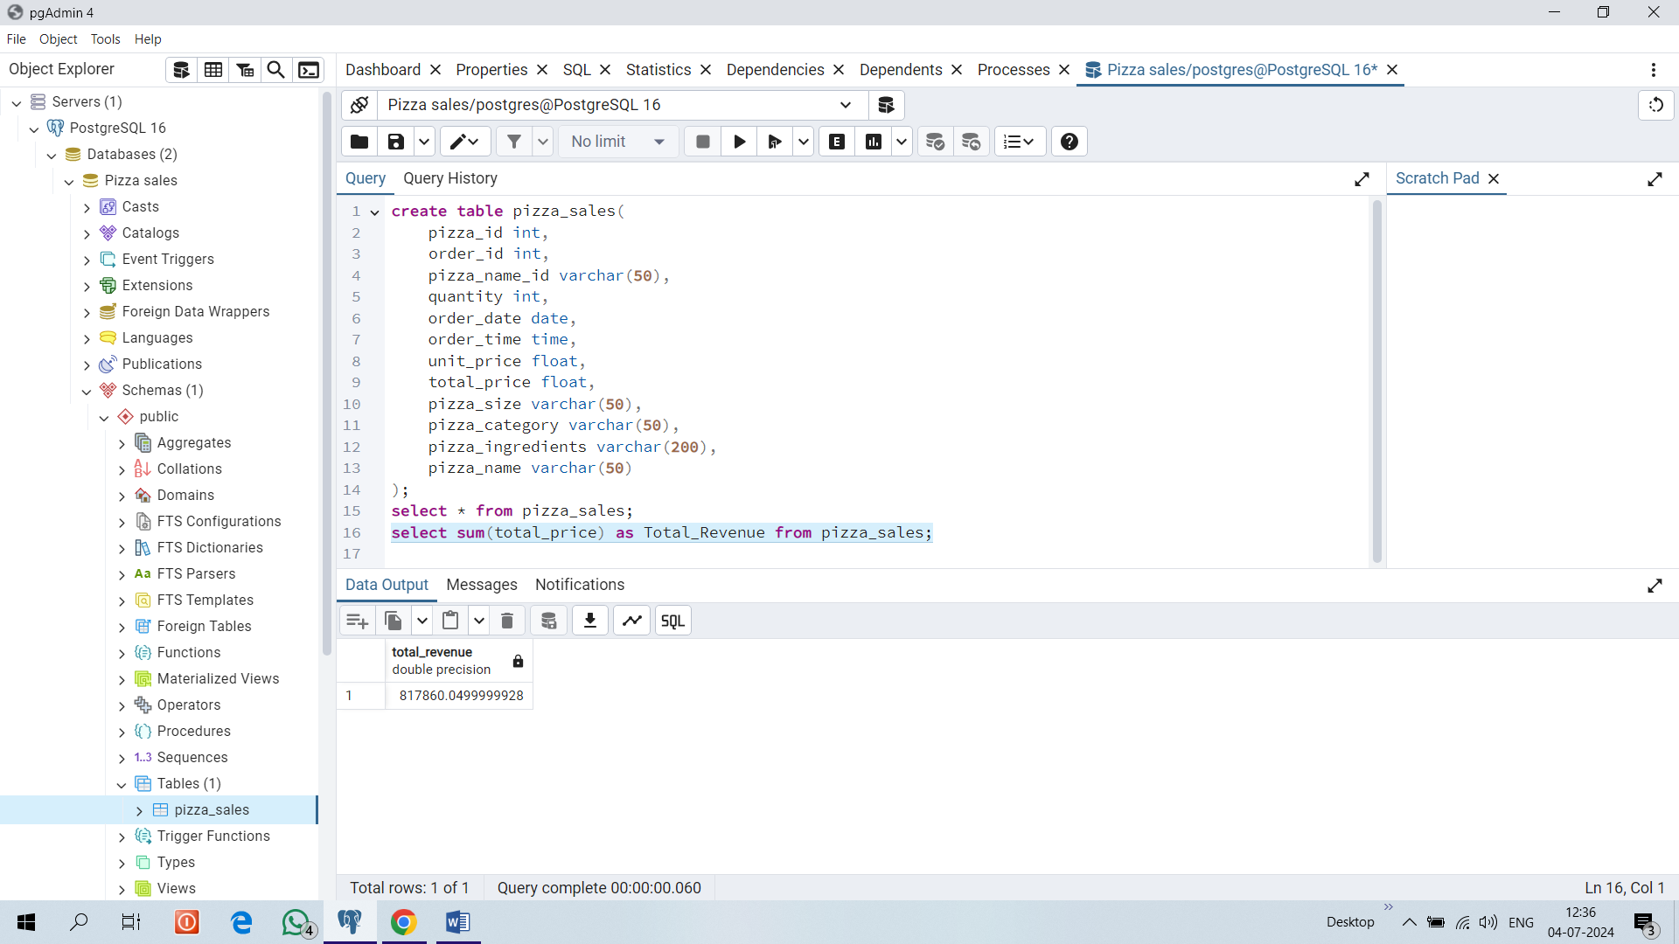

**2. AVERAGE ORDER VALUE**

select sum(total_price)/count (distinct order_id) as Avg_Order_value from pizza_sales;

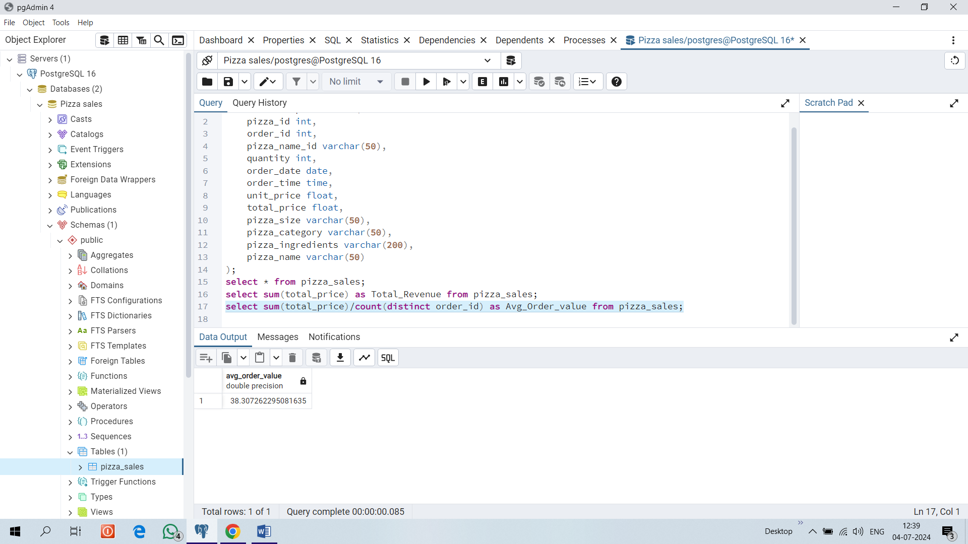

**3.TOTAL PIZZAS SOLD**

select sum(quantity) as Total_pizzas_sold from pizza_sales;

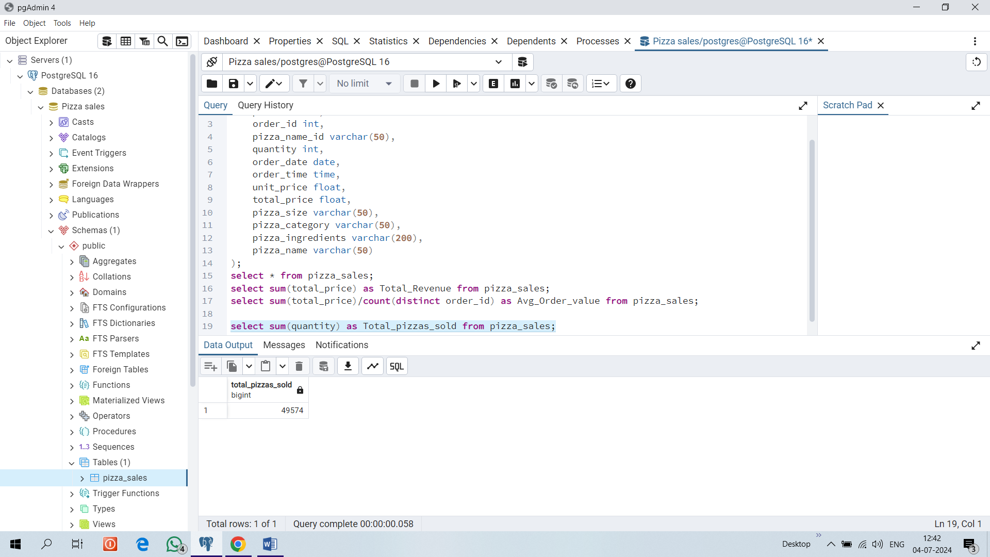

**4. TOTAL ORDERS**

select count (distinct order_id) as Total_orders from pizza_sales;

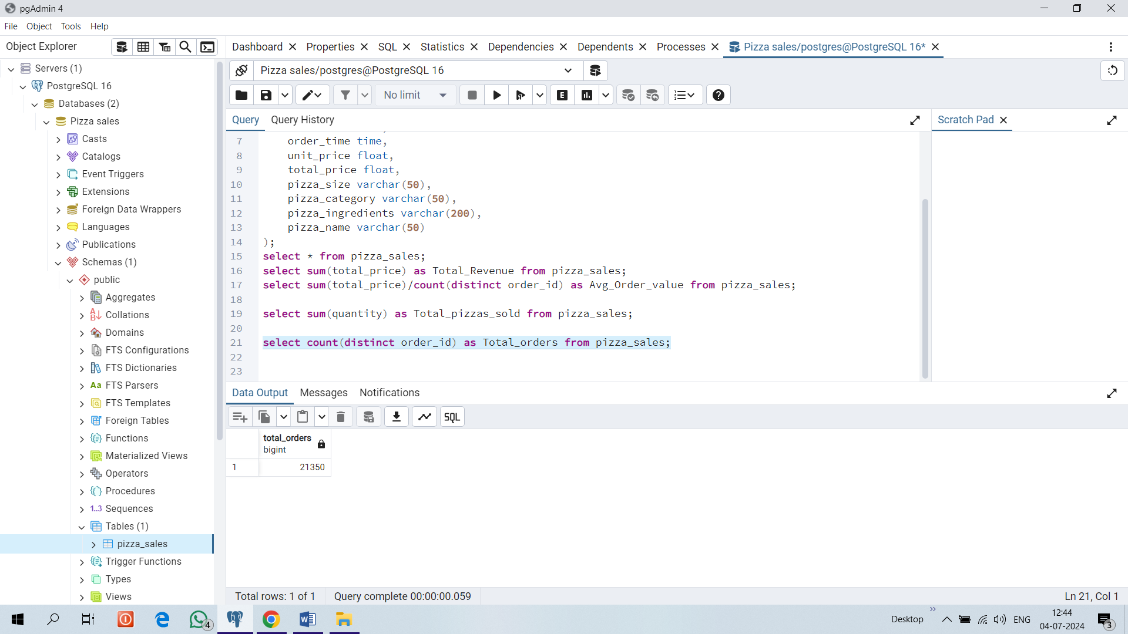

**5. AVERAGE PIZZAS PER ORDER**

select cast (cast (sum(quantity)as decimal (10,2))/

cast (count (distinct order_id) as decimal(10,2)) as decimal(10,2)) as avg_pizzas_sold from pizza_sales;

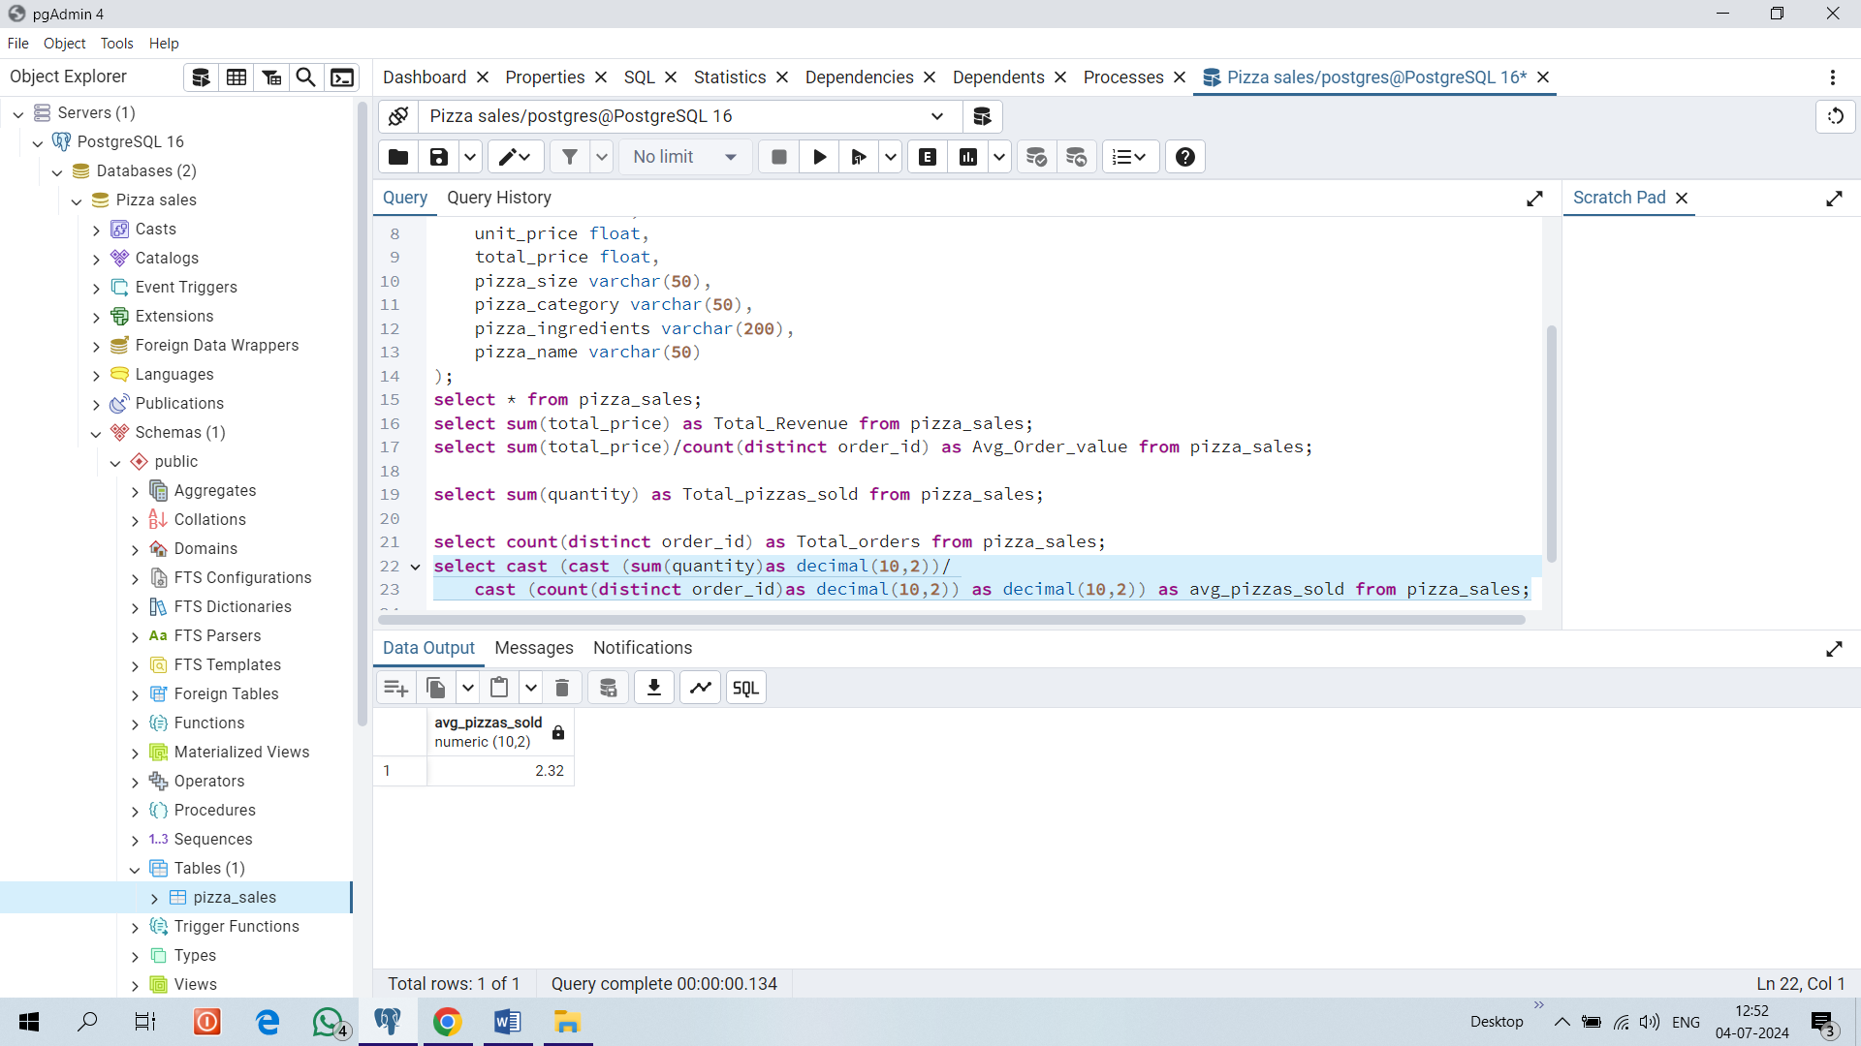

**6. DAILY TREND FOR TOTAL ORDERS**

select to_char(order_date,'day') as order_day, count (distinct order_id) as total_orders from pizza_sales

group by to_char(order_date,'day');

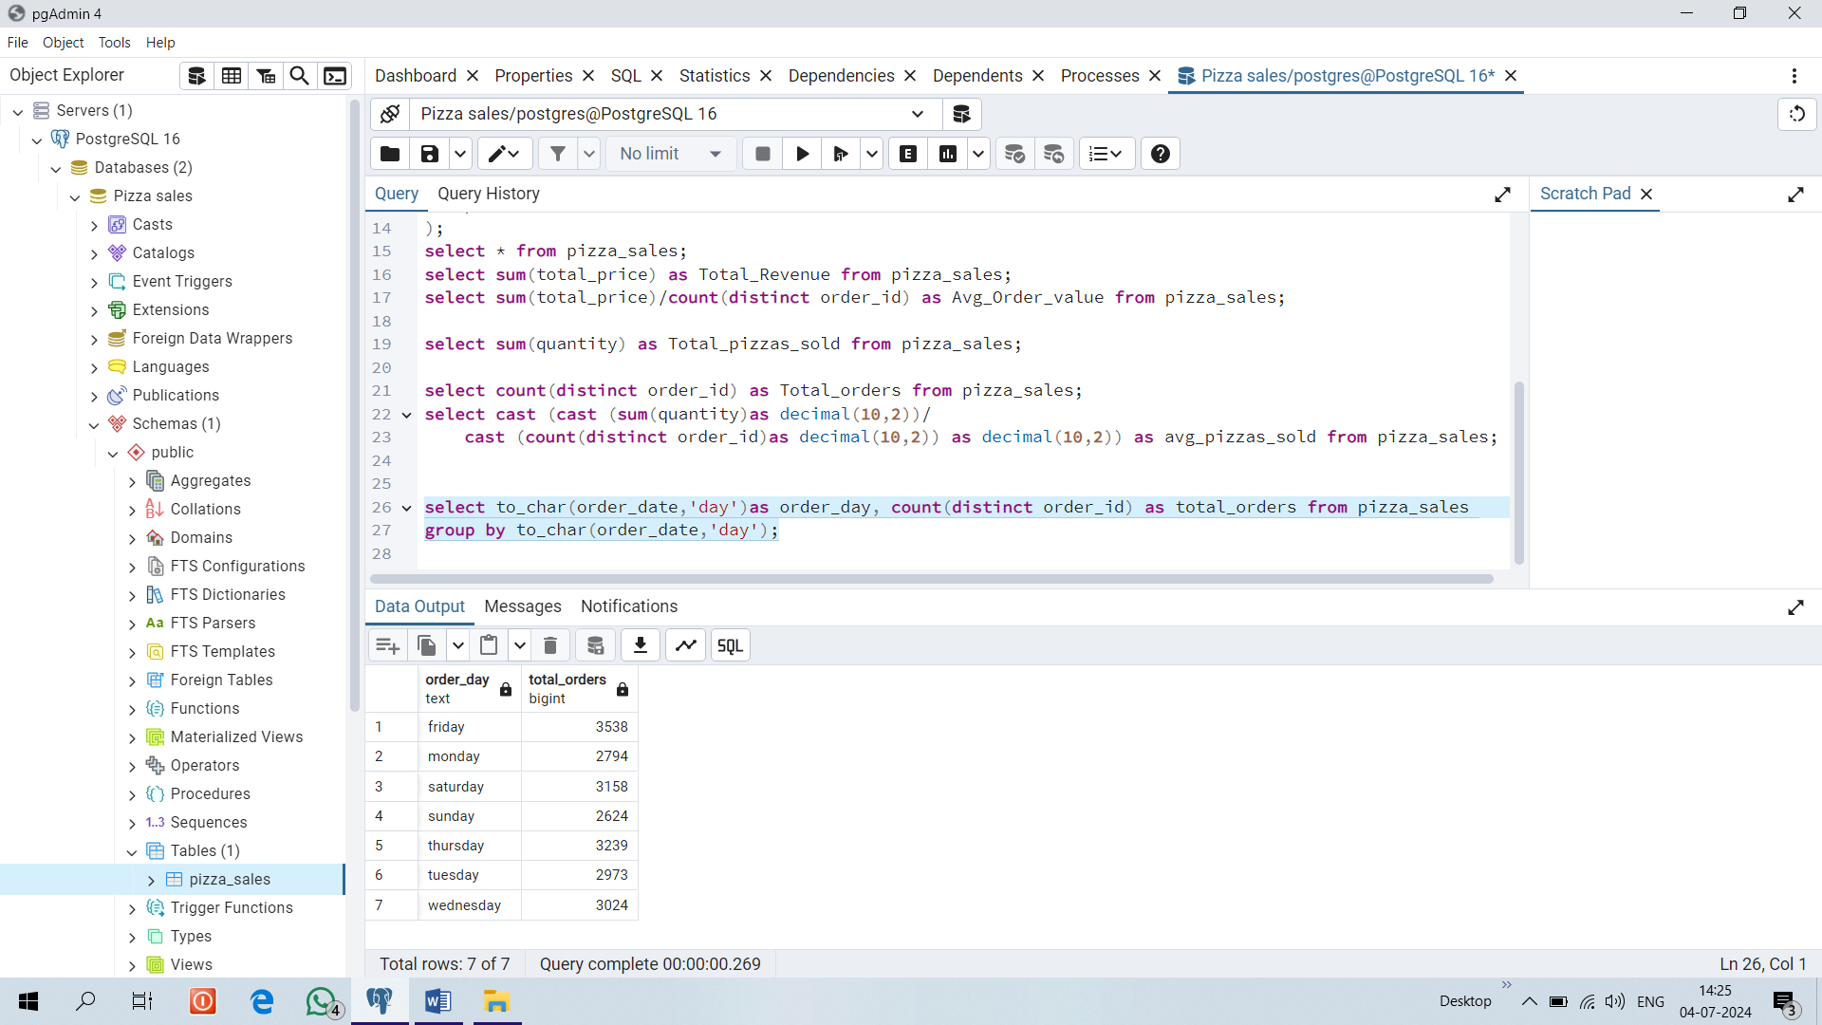

**7. HOURLY TREND FOR ORDERS**

select extract (hour from order_time) as order_hours, count (distinct order_id) as total_orders

from pizza_sales group by extract (hour from order_time)

order by extract (hour from order_time);

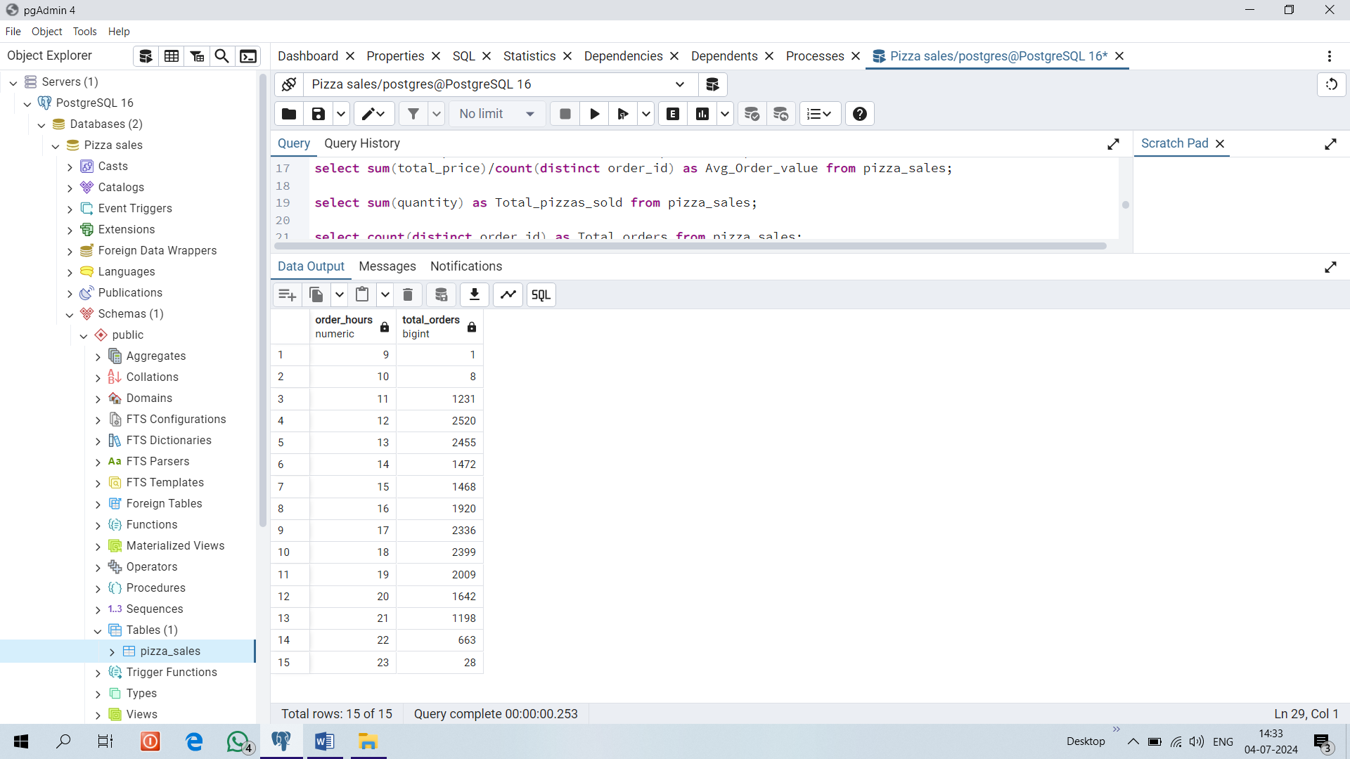

**8. % OF SALES BY PIZZA CATEGORY**

select pizza_category, sum(total_price) as total_sales,

sum(total_price) *100 / (select sum(total_price) from pizza_sales) as sales_percent

from pizza_sales

group by pizza_category;

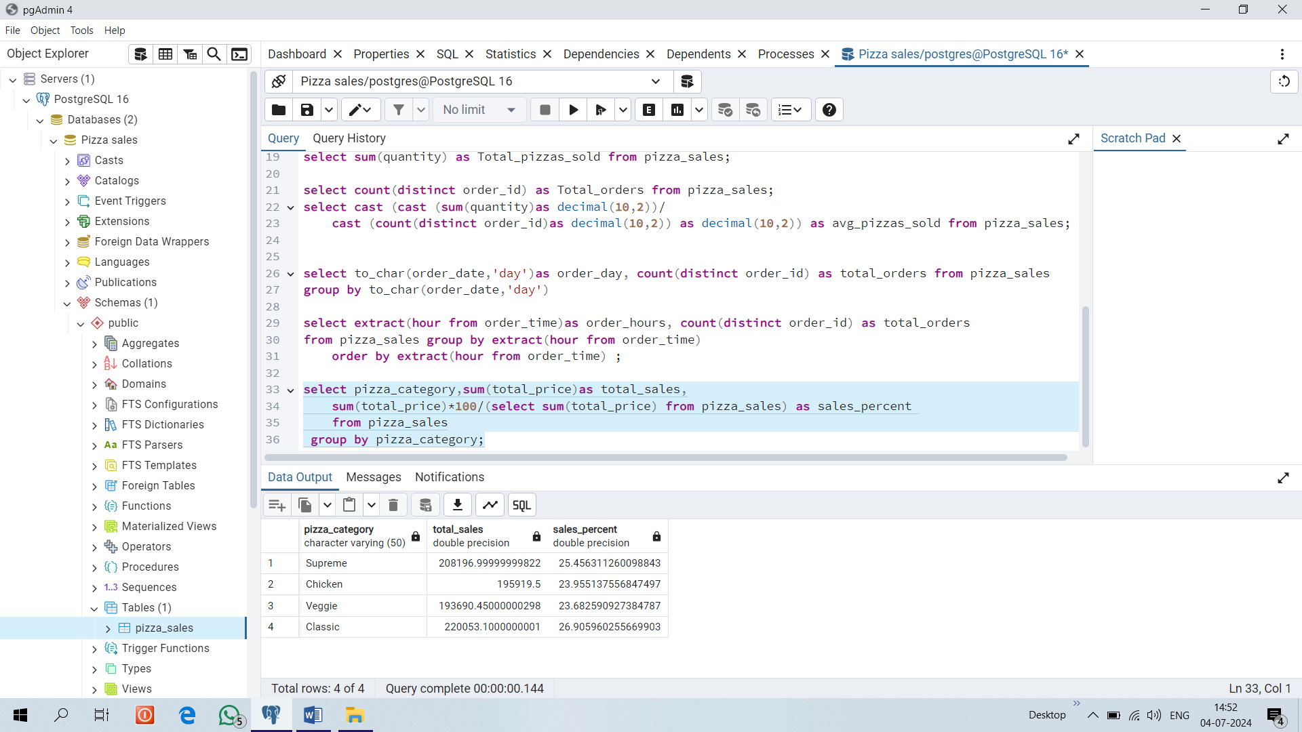

**9. % OF SALES FOR A PARTICULAR MONTH BY PIZZA CATEGORY**

select pizza_category, sum(total_price) as total_sales,

sum(total_price) *100 / (select sum(total_price) from pizza_sales where extract (month from order_date) =1)

as sales_percent

from pizza_sales where extract (month from order_date) = 1

group by pizza_category;

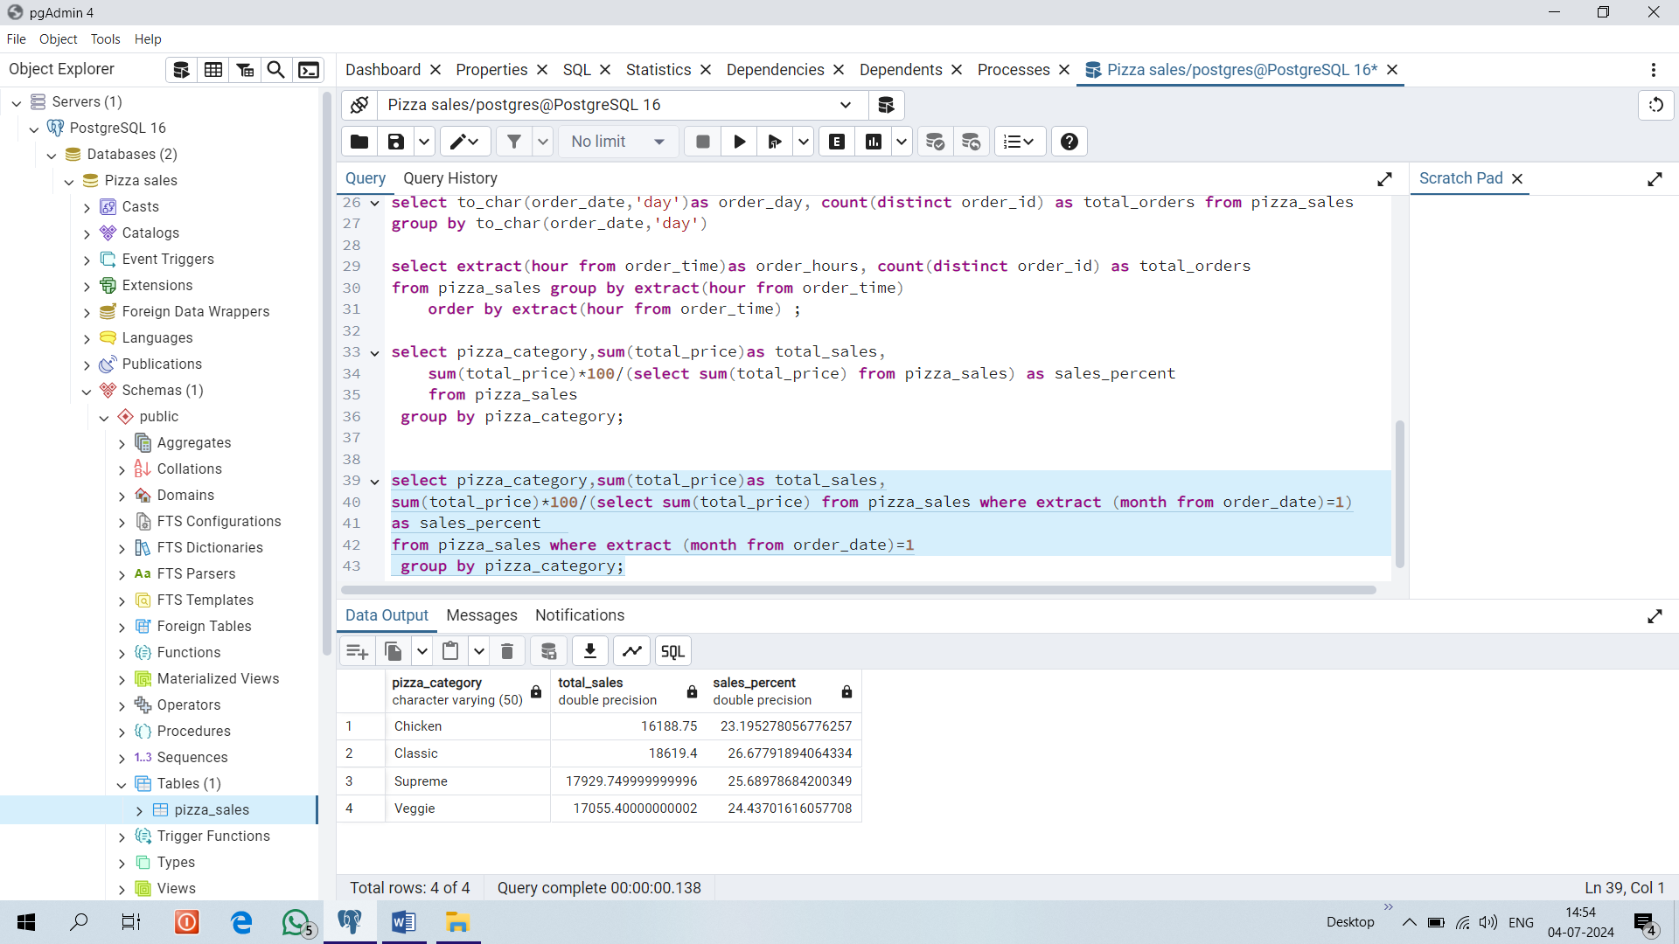

**10.% OF SALES BY PIZZA SIZE**

select pizza_size, sum(total_price) as total_sales,

sum(total_price) *100 / (select sum(total_price) from pizza_sales)

as sales_percent

from pizza_sales

group by pizza_size order by sales_percent;

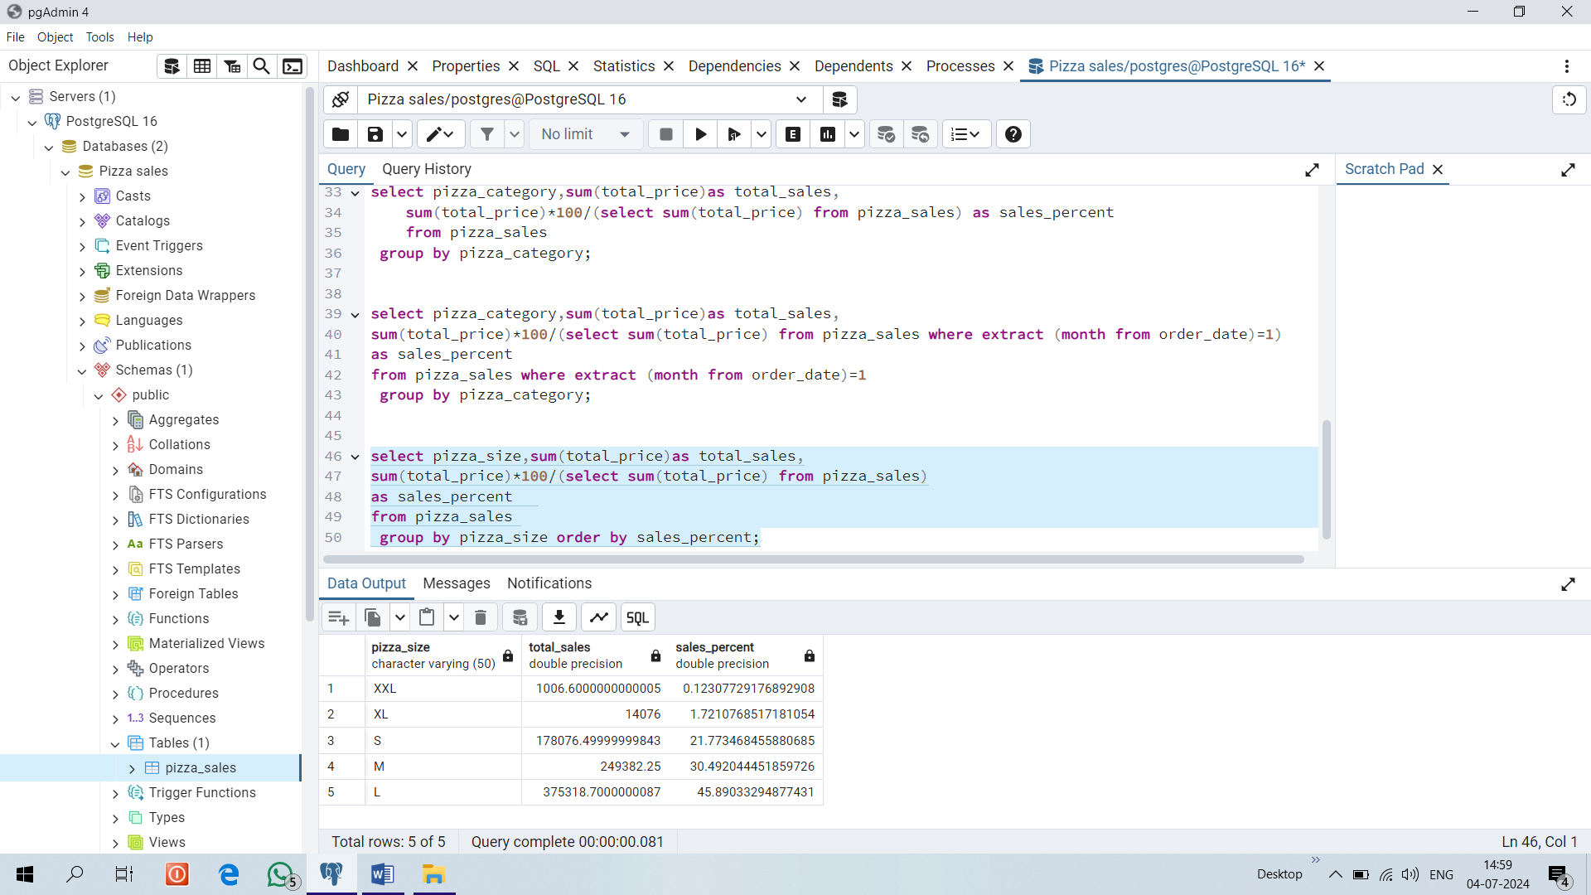

**11.% OF SALES FOR A QUARTER BY PIZZA SIZE**

select pizza_size, sum(total_price) as total_sales,

sum(total_price) *100 / (select sum(total_price) from pizza_sales where extract (quarter from order_date) =1)

as sales_percent

from pizza_sales where extract (quarter from order_date) =1

group by pizza_size order by sales_percent;

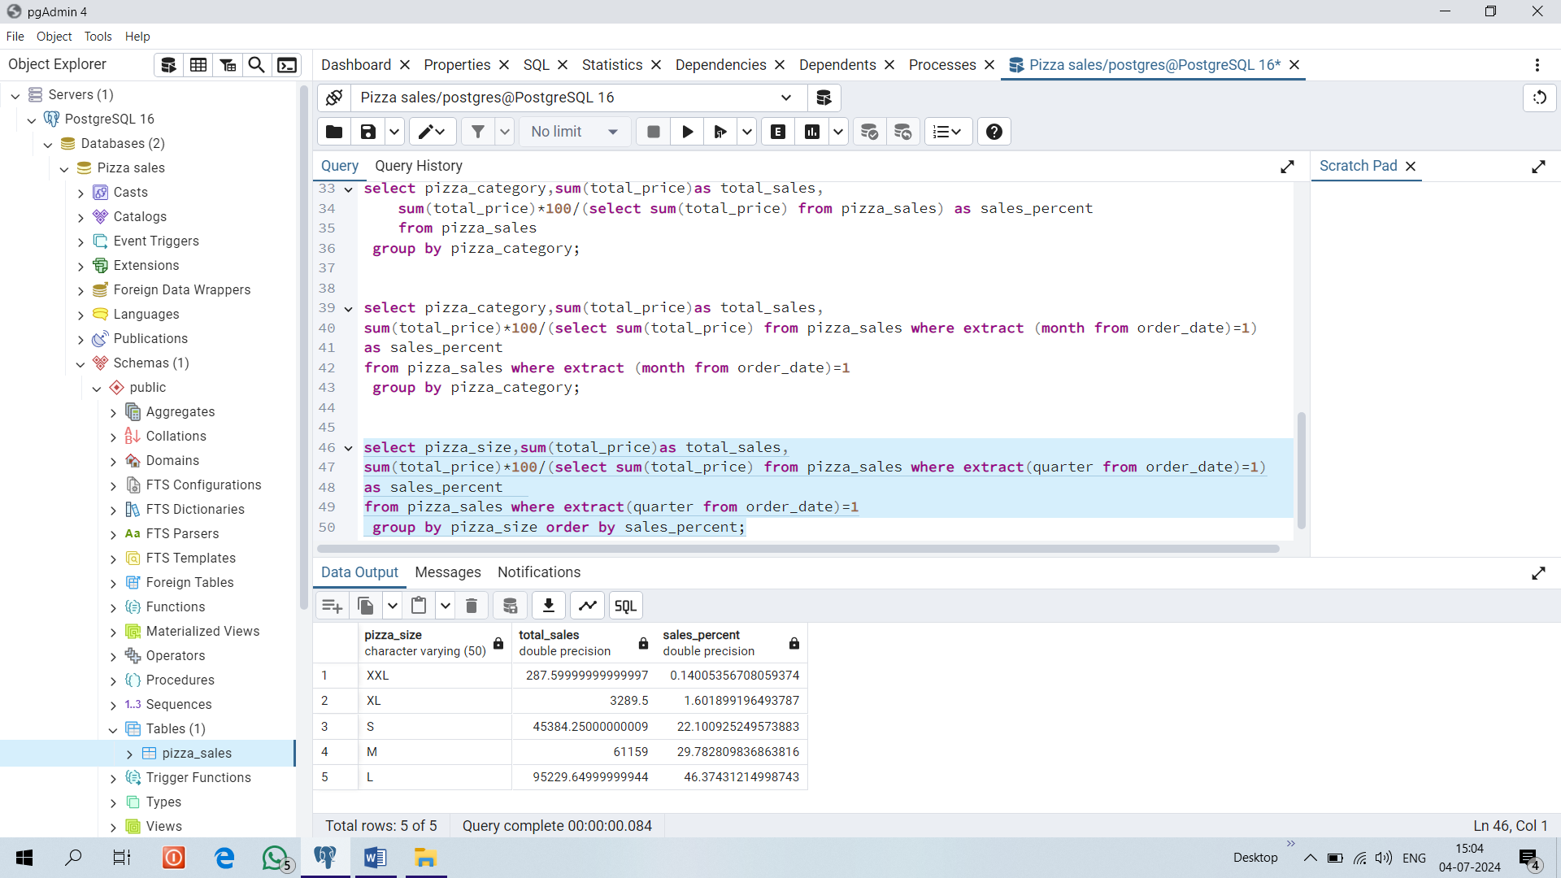

**12.TOTAL PIZZAS SOLD BY PIZZA CATEGORY**

select pizza_category, sum(quantity) as total_pizzas_sold from pizza_sales

group by pizza_category;

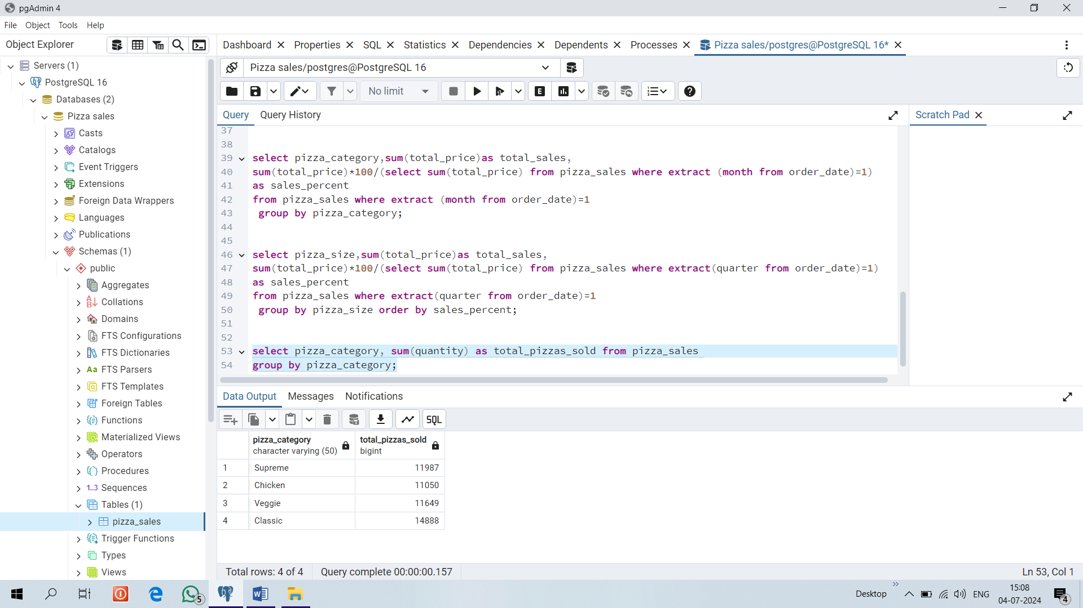

**13. TOP 5 BEST SELLERS BY TOTAL PIZZAS SOLD**

select pizza_name, sum(quantity) as total_pizzas_sold from pizza_sales

group by pizza_name

order by total_pizzas_sold desc limit 5;

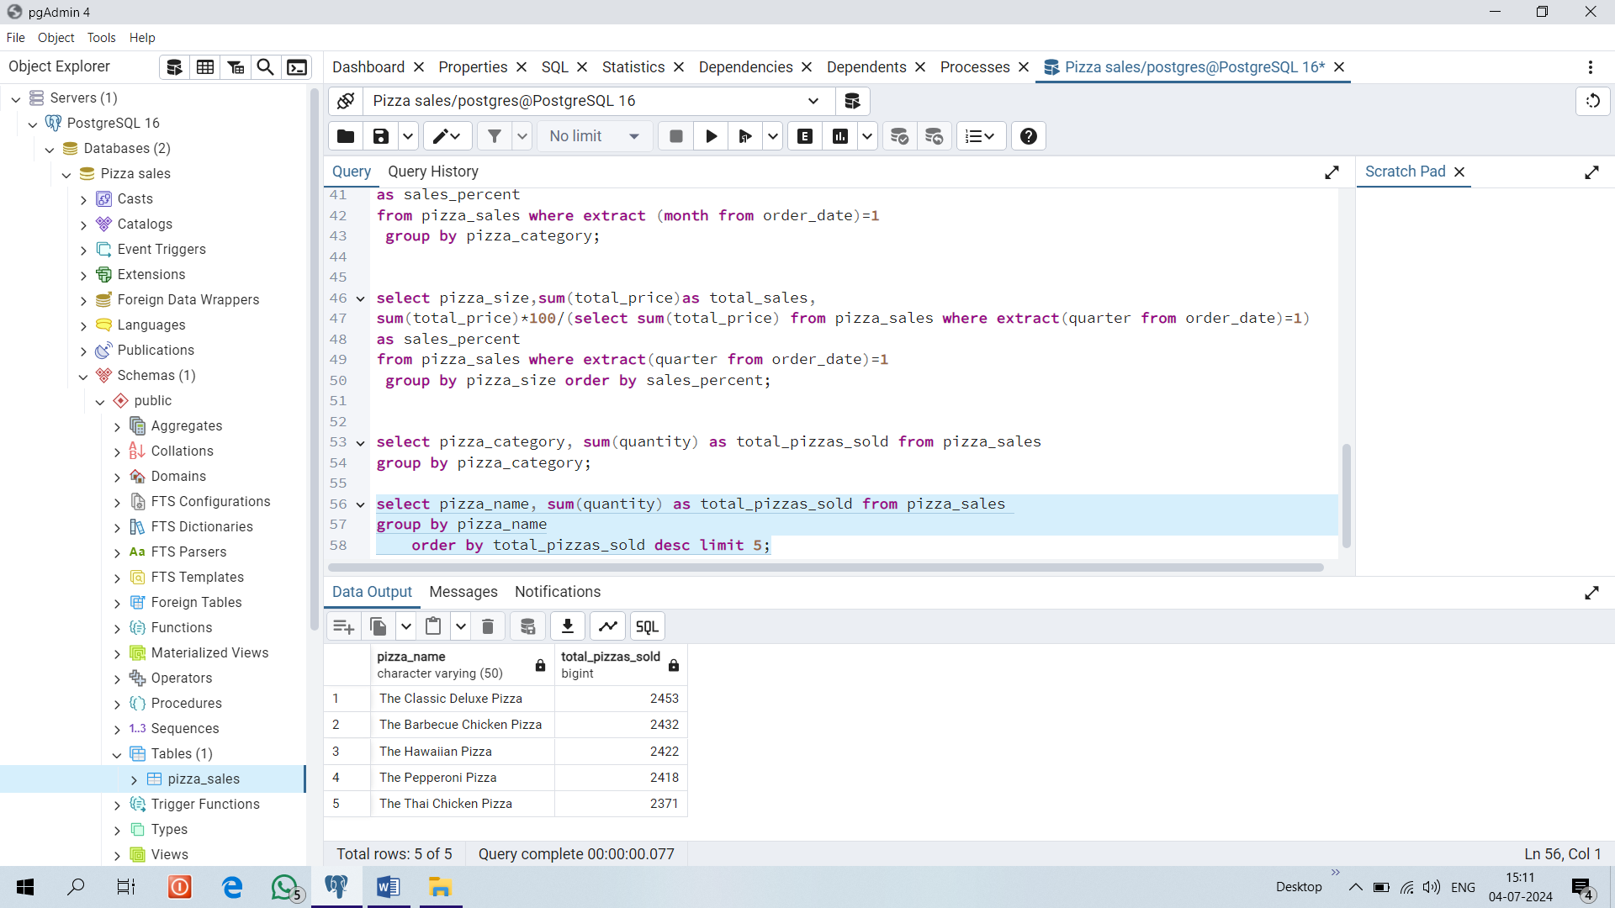

**14.BOTTOM 5 BEST SELLERS BY TOTAL PIZZAS SOLD**

select pizza_name, sum(quantity) as total_pizzas_sold from pizza_sales

group by pizza_name

order by total_pizzas_sold limit 5;

